

Pacific Southwest Academy of Legal Studies in Business

ANNUAL BUSINESS LAW CONFERENCE

PRESIDENT’S DAY WEEKEND 2022

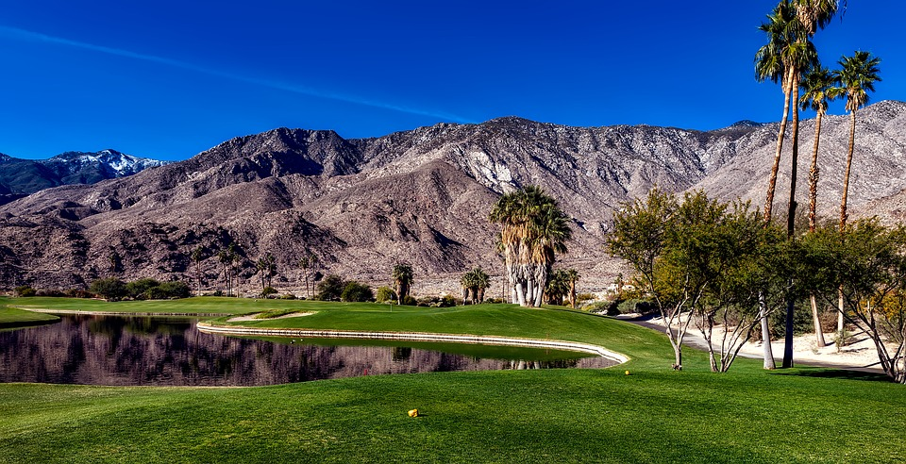

**FEBRUARY 17-20, 2022**

**HILTON PALM SPRINGS RESORT**

**Enjoy some desert weather, present a paper, get great educational experience[1],**

**and meet and exchange ideas with colleagues!**

**Paper submissions eligible for cash awards of $500.00, $200.00 and $100.00.[2]**

The Journal of Law, Business and Ethics is sponsored by the PSWALSB. Open submissions.

**Registration fee: $295.00 prior to December 15th**

(includes receptions, breakfasts and Saturday night banquet)

Reserve your hotel room early to get the $195.00/night group rate (group code “PAC”)

For information and registration visit the PSWALSB website at www.pswalsb.com

or contact 2022 Conference Chair Sona Gala at Sona.Gala@lmu.edu.

1. Past conference attendees have received 6-8 hours of CLE credit.
2. Eligibility for prizes subject to rules and conditions. Please see PSWALSB website for further details.